* Business challenge
  1. The finance department is having issues with incorrect salary payments to its employees.
* Sponsors

1. Leona Clark- payroll manager
2. Tshepo Maswanganye- Solutions architect

* The finance department focuses on taking care of multichoice finance, such as paying the employees their salaries. The issue of incorrect salary payments occurs within Payroll division.
* Strategic focus areas
  + 1. Engage with our community
    2. Improve team efficiency
    3. Provide a user-friendly solution
    4. **Provide a working solution (solves specific problem)**
* SWOT analysis

**STRENGTHS**

-Variety of skills and knowledge

-Effective communication among each other

-Time effective and user-friendly

- **Software Tool availability**

**- Strong Management**

- ***What assets do you have in your team, such as knowledge, education, network, skills, and reputation?***

***The team has knowledge distribution to execute the solution. Experience in Databases (SQL Server), Backend programming (C# and Python) and frontend (React). The Team is dynamic as it is willing to learn even technologies outside this scope. The team’s primary focus is to solve real problems, build and provide working solutions to be recognized as Solution providers***

**- *What physical assets do you have, such as customers, equipment, technology, cash, and patents?***

***- The team has the software they need to execute the project i.e. MS SQL server, Visual Studio licensed version etc (Provide as a team). Data schema will be provided to work as dummy data for the solution***

***(Strong Management - We have assembled a team that embraces different disciplines with expertise in all areas of the business)***

**WEAKNESS**

-Given insufficient information and being misinformed

-Limited resources

-Time management

- **Currently the department is relying on manual operations which is time intensive and error prone**

***Are there gaps on your team?***

**-The team’s skills in different technologies is not very comprehensive.**

**OPPORTUNITIES**

-Learn new and advanced technology skills

- Build new relationships and get more exposure across MultiChoice

- Improve the payroll process by automation (data extraction from Database)

- Analytics and machine Learning: **Acquired Data can benefit the payroll department in Business Intelligence through available monthly data. They will be able to monitor and evaluate salary trends for future analytics and machine learning**

- **Continuous Integration**: **providing a dynamic solution that can be improved over time to meet business needs eg integrating analytics to the solution**

**THREATS**

- Securing the data

- Not meeting the scheduled time

- **Risk of data interception (as this contains confidential employee salary information), provide compliant security measures on the data and webservice (stored procs)**

- **Access to confidential data (Ethics and Governance)**

* Stakeholder analysis

1. Collect the data – Payroll division (Leona Clark)
2. Help solve the problem

- CII-business advisory (Yogan Naidoo)

- Connected Video (Tshepo Maswanaganye)

-Technology-SDE (Naveena Ningegowda)

1. The developers-Mind benders

* Rich Picture

**Key learnings as a group**

1. Planning before solving the problem

2. Collaboration, communication and time management

3. Respecting each other as a team

4. Team willingness to progress and continuously learn

5. Team is passionate about the success of the project as it is solving a real problem

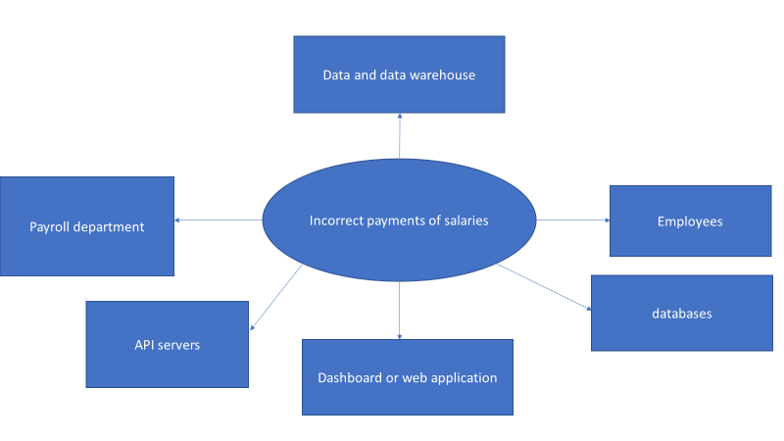

* Issue

1. The payroll department is having problems with identifying the salary discrepancies and it is time consuming since it is done manually which result in human errors.

* Project plan

1. Collect the data
2. Research and consult on technology we can use
3. Design application mockups
4. GUI design
5. Start development